The Star Report: Observation of a Second Firing Pin Impression

By: Nancy D. McCombs, California State Department of Justice, 6014 N. Cedar, Fresno, CA 93710

Key Words: Cartridge Case, Star Pistol, Firing Pin Impression

ABSTRACT

An unusual impression was observed on cartridge cases fired from an ill-fated 9mm
Star pistol. The impression, located above the firing pin drag mark, was identified as a second firing pin impression. Initially this occurrence was thought to be unique to this pistol. However, a second firing pin impression was observed on cartridge cases fired from various models and calibers of Star pistols.

INTRODUCTION

Rifling characteristics on the surface of bullets have long been used to help identify the manufacturer of suspect weapons. In more recent years, characteristic markings on fired cartridge cases have also proven useful in identifying or predicting the manufacturer of suspect weapons. Information derived from both bullets and cartridge cases is a powerful combination that can significantly reduce the number of candidate weapons.

Often the markings observed on fired cartridge cases are artifacts and bear no particular significance. Occasionally, cartridge case marks are uniquely characteristic of a particular manufacturer. In one instance, cartridge cases fired from an ill-fated Star pistol revealed some very unusual and reproducible impressions.

BACKGROUND

On March 17, 1990, a 43-year-old man committed suicide with a 9mm Star pistol. Eight years later his son used the same Star pistol to fire several shots at a police SWAT team during an arrest attempt. One officer was killed by a bullet that found its mark through an armhole in his bulletproof vest. In return, over 60 shots were fired at the 16 year-old boy by the remaining members of the SWAT team. Subsequent examinations linked the 9mm Star pistol to two additional assaults and an attempted homicide.

EXAMINATION

A very curious mark was found on cartridge cases fired from the 9mm Star pistol. Along with the familiar characteristics commonly associated with cartridge cases (extractor, ejector, firing pin, chamber and breechface marks), was an additional impression. The impression was usually circular or hemispherical, and was located above the firing pin impression generally between twelve and one o’clock. Upon further examination, this mark was determined to be a second firing pin impression. (Figure 1)

Figure 1: Image of second firing pin impression produced by a Star model BM
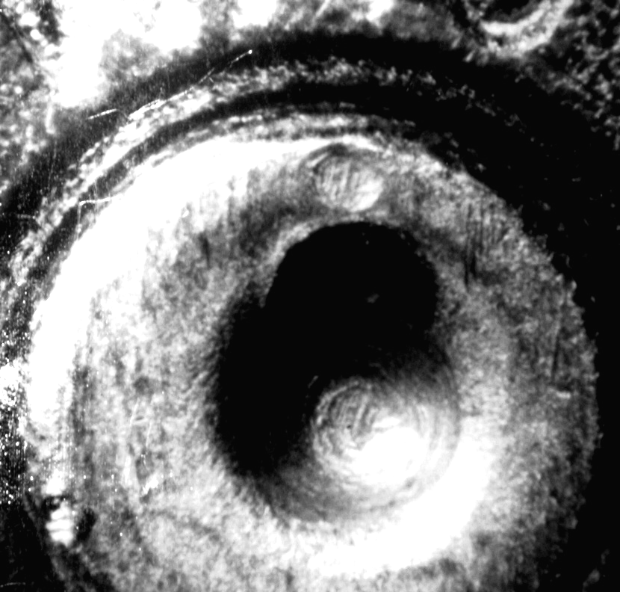

A logical assumption is the additional firing pin impression stems from some kind of aberrant characteristic unique to this particular pistol. However, this premise is false. Fired cartridge cases from several 9mm Star pistols were examined. The majority of these pistols displayed a second firing pin impression on the cartridge cases. Star pistols from various other calibers also displayed this peculiar impression. While this mark has been previously observed on 9mm cartridge cases from one model of Star pistol, it was described as an “unknown mark.” [3]

Star pistols are also notorious for primer shearing. During the unlocking of the breech, a portion of the primer is shaved off by the coarse edges of the firing pin aperture producing two triangular shaped toolmarks above the firing pin impression. Combined, the two triangles and the firing pin impression resemble a cat’s head and consequently have been dubbed “cat’s ears.”

Cartridge cases from 24 Star pistols were examined for the presence of a second firing pin impression and/or
“cat’s ears.” The cartridge cases were obtained from Laboratory test fires dating back as far as 1976 or generated from Laboratory reference pistols.

As depicted in table 1, the existence of a second firing pin is independent of caliber, model or the presence of
“cats ears.” The second firing pin impression was usually positioned at twelve or one o’clock and was produced by well over half the Star pistols in this study.

Table 1: Presence and position of second firing pin impression and presence of “cat’s ears”

Cartridge |  |  | Presence of 2nd | Position of 2nd | Presence of
Case | Caliber | Model | FP Impression | FP Impression | "Cat's Ears"
1 | .380 | * | No | ------ | Yes
2 | .380 | SA | Yes | 12 | Yes
3 | .380 | SS | Yes | 1 | Yes
4 | .380 | SA | Yes | 1 | Yes
5 | 38 | * | Yes | 12 | No
6 | 9mm | BM | Yes | 12 | Yes
7 | 9mm | BM | No | ----- | Yes
8 | 9mm | SA | Yes | 1 | No
9 | 9mm | * | Yes | 1 | Yes
10 | 9mm | AS | Yes | 12--1 | Yes
11 | 9mm | * | No | ------ | No
12 | 9mm | * | Yes | 1 | Yes
13 | 9mm | Super | No | ------ | No
14 | 9mm | * | No | ------ | No
15 | 9mm | BM | Yes | 11 | Yes
16 | 9mm | B | Yes | 11--12 | No
17 | 9mm | SA | Yes | 1 | Yes
18 | 9mm | * | Yes | 1--2 | No
19 | .45 | * | No | ------ | No
20 | .45 | Firestar | Yes | 1 | Yes
21 | .45 | Firestar | Yes | 12 | No
22 | .45 | SA | No | ------ | Yes
23 | .45 | PD | No | ------ | No
24 | .45 | * | No | ------ | No

* Model not recorded by examiner

DISCUSSION

Dual firing pin impressions are commonly produced by .22 rimfires, and pistols utilizing a blowback design with a firing pin ejection mechanism, such as the 9mm Stallard Arms. [3] It is interesting that the CZ model 83 pistol, which has a blowback design with a separate ejector, has also been reported to produce a second firing pin impression. [4, 5] Star pistols, however, utilize a Browning locked-breech design and have a separate ejector. Double firing pin impressions are not usually produced by pistols having this type of mechanism.

Although the exact cause of the second firing pin impression has not been determined, one possible explanation is the firing pin spring inherent to the Star pistol causes the firing pin to “bounce” off the hammer and strike the cartridge case more than once. To test this theory, the firing pin spring was replaced with a spring from a firearm that did not produce a second firing pin impression on its fired cartridge cases. Despite the changed spring, two firing pin impressions were still observed on the fired cartridge cases. In fact, a second firing pin impression persisted even when the firing pin spring was completely removed.

In Star pistols and the CZ model 83 pistol, the firing pin protrudes slightly from the breech face when the hammer is down. [5, 6] In other words, the firing pin never fully retracts. Therefore, the second firing pin impression most likely occurs when pressure from the expanding gases force the cartridge case back against the breech face, where it re-contacts the projecting firing pin.

SUMMARY

A second firing pin impression together with “cat’s ears” represent sub-class characteristics that strongly point to a Star pistol as the suspect weapon. If sufficient detail exists, the second firing pin impression provides additional toolmarks that can assist in obtaining an identification.

REFERENCES

[1] Hamman, John, California State Department of Justice, Fresno Laboratory, Personal Communication

[2] Hoober, Steven, Sprint PCS, Internet Communication

[3] Kennington, Robert, The Matrix: 9mm Parabellum and Personal Communication

[4] Eaglefield, Mike, CZ U.S.A., Personal Communication

[5] Koffman, Avi, and Howard Silverwater, “Double Firing Pin Strike of the CZ Model 83 Pistol-Study of the Phenomenon,” AFTE Journal, Vol. 31, No. 1, Winter, 1999, pp. 36-42.

[6] National Rifle Association. NRA Guide to Firearms Assembly. NRA Press, 1980. Book II: Pistols and Revolvers;
Star Model BS Pistol by Ludwig Olsen, p. 477.

[7] Spatola, Josh and Ray Silva, California Criminalistics Institute, Personal Communication

ACKNOWLEDGMENT

The author would like to thank Andrea Van der Veer De Bondt of the Fresno County Sheriffs Department Laboratory for her assistance with the editing of this paper.

